**(supporting materials on the web: ViennaRANWebServers.ppt and Viennatutorial.mov)**

**RNA folding Exercise**

1. This is a mRNA sequence of the HLA-DRB1 gene in fasta format:

>gi|327202284|gb|HQ331237.1| Homo sapiens MHC class II antigen (HLA-DRB1) gene, HLA-DRB1*14 allele, exon 2 and partial cds

CACGTTTCTTGGAGTACTCTACGTCTGAGTGTCATTTCTTCAATGGGACGGAGCGGGTGCGGTTCCTGGA

CAGATACTTCCATAACCAGGAGGAGTTCGTGCGCTTCGACAGCGACGTGGGGGAGTACCGGGCGGTGACG

GAGCTGGGGCGGCCTGCTGCGGAGCACTGGAACAGCCAGAAGGACCTCCTGGAGCGGAGGCGGGGCCGGGTGGACACCTATTGCAGACACAACTACGGGGTTGTGGAGAGCTTCACAGTGCAGCGGCGAG

a) Design siRNAs using the vienna webservers, to be used to silence the gene. List out all the potential siRNA sequences which can be used to silence this mRNA.

b) Construct the secondary structures of all the potential siRNAs above and determine their mfe values. Paste the secondary structures and their corresponding mfe values in your answer.

c) Which siRNA do you think would be the best candidate?

d) Predict the mfe values of heterodimers and homodimers in a solution of mRNA and the siRNA you thought was the best candidate. Do you think such a heterodimer could exist in nature?

2) Use the secondary structure below to answer the questions:

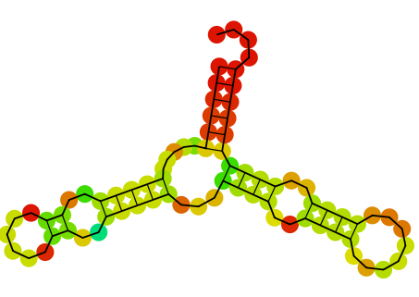

1. Draw a dot-bracket diagram to depict this secondary structure.
2. Construct a RNA sequence, which will have this secondary structure.
3. Deduce the mountain plot for this sequence.

NOTE: for help see ViennaRNAtutorial.mov (21 min) and ViennaRNAWebServers.ppt