Dear Dr. Alexei Fedorov,
I would like to share with you basic information on the family of autosomal recessive retinal dystrophy as depicted below.

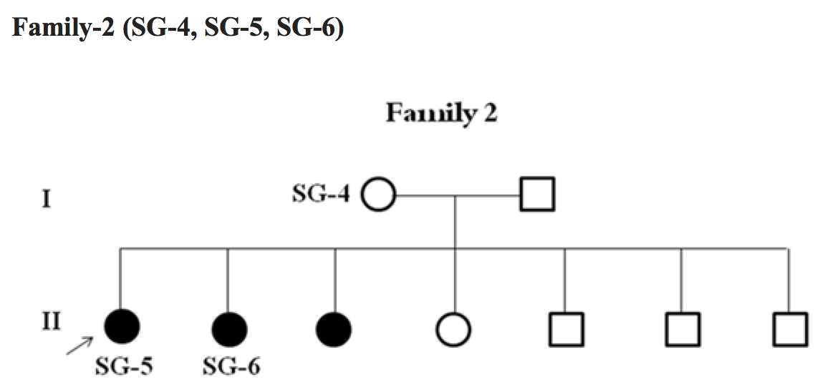

We have carried out whole exome sequencing on Illumina Hiseq platform using Agilent SureSelect Human All Exon V5 Kit in the affected girl (SG-5), her affected sister (SG-6) and healthy mother (SG-4).

We have provided you fastq files (100 bp pair end sequencing, R1 and R2 files for each individual) of the three family members SG-4, SG-5 and SG-6.

This family as shown in pedigree seems to follow autosomal recessive pattern of inheritance. There are two possibilities:
1. The causal mutation can be homozygous recessive. It should be present in single copy in the mother (SG-4) as she is supposed to be carrier. It should be present as two copies of the same mutation in the affected daughters (SG-5 and SG-6). Such a mutation is generally present in a large block of homozygous markers in the genome of patient. This is more common in consanguineous family. Our family is NOT consanguineous so this kind of mutation is less likely here.
2. It can be a compound heterozygous mutation. We expect the causal mutation in this family to be compound heterozygote. In this case, affected children (SG-5 and SG-6) will have two heterozygous variants (different alleles) at different positions in the same gene. One variant/allele of this compound heterozygous mutation is inherited from mother (mother should be heterozygous for that allele/variant) and another one comes from father(father should be heterozygous for that allele/variant).

Variant calling (SNPs and INDELs) should be performed using standard procedures of GATK or Samtools. Summary reports of variants called from each sample should be provided; number of SNPs, INDELs, homozygous and heterozygous variants and transition to transversion ratio, read depth and quality distribution of identified variants in each sample should be provided. Variant calling should be done individually and together (all samples together to produce single VCF file for all samples). Variant filtration should be done using standard procedures and parameters.

Regards
Mousumi

Mousumi Mutsuddi, PhD
Asst Professor
Department of Molecular and Human Genetics
Banaras Hindu University, Varanasi-221005

